NLSR Routing Status Page

System Overview
The system is consisted of the following components:
- Consumer-side components: Browser.
- Producer-side components: Websocket Proxy, NFD, NLSR.
Interaction among components
Clients' browser will send interest embedded in http request for NLSR status of a remote node. Remote node's Websocket Proxy will receive the request and pass the decapsulated interest to local NFD. NFD will, then, send interest to local NLSR requesting status data. Upon receiving status data from NLSR, NFD will pass it to Websocket Proxy that sends the data to the Client. The following diagram shows the interaction among different components of the system.
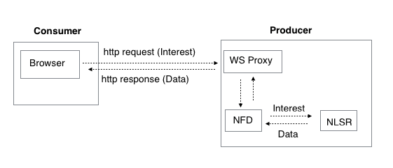
System Implementation
The webpage will be written in JavaScript and ndn-js (JavaScript Library for NDN) will be used for implementation.
Data that will be displayed on Webpage
The current status page displays following information:

Name LSA:
- Origin router
- Timestamp
- Name prefixes advertised by the router
Adjacent LSA:
- Origin router
- Timestamp
- Neighboring routers (aka adjacents or links) of the router
In addition to displaying the above-mentioned information, the new webpage will also display the following Coordinate LSA information:
Coordinate LSA:
- Hyperbolic radius
- Hyperbolic angle

