LSA Segment Publisher
There will be an NlsrSegmentPublisher class that will take an Nlsr’s certificate-name as parameter and this Nlsr’s identity will be used for signing each data segment. This way if we later have other publisher that needs to be signed by the NLSR identity, we can directly inherit from NlsrSegmentPublisher. LsaPublisher will inherit from NlsrSegmentPublisher class, which is an abstract class, and the former has to implement the generate() abstract method of the latter.
The current implementation of SegmentPublisher will be modified and will be turned into NlsrSegmentPublisher.
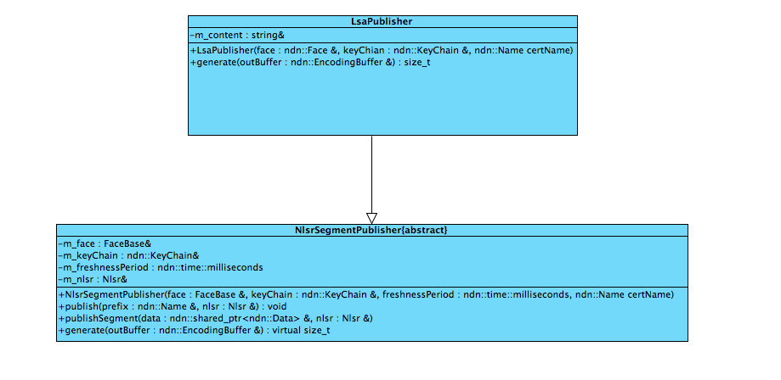

LSA Segment Fetcher
For implementing LSA Segment Fetcher, we just need to write four methods (one for each LSAs and one more for listing all the LSAs) in the LSDB class that will construct SegmentFetcher class and invoke fetch() method of the latter class with necessary interest names.

